Advanced Scripting   
Exercise 2.1 Interactive Shell

Last Updated: 4/27/2021 7:24 AM Version 1  
Document Prepared for: CIT361 Student

# Name Ryan Skidmore ID 615907798

# Instructions

Answer all questions directly in this document. You will save and upload this completed document as your homework submission.

# Overview

In this exercise, you will use PowerShell to start programs and perform simple calculations.

# Setup

## Requirements

* Windows PowerShell

# Task 1—Running programs in your path

Use PowerShell to run programs. You can run any program that is in your path by simply typing the name of the program in the shell and pressing Enter

## Steps

1. Start PowerShell
2. Start notepad by entering the following command  
   notepad
3. This should start notepad. The reason this works is that notepad is in the system’s search path.
4. Let’s find your default gateway. Enter the command  
   route print
5. Look for a line that starts with 0.0.0.0. It will look something like this  
     
   What is address of the gateway on your computer? 10.0.0.1
6. There are many programs (commands) included in your search path. Here is link to [Windows commands](https://docs.microsoft.com/en-us/windows-server/administration/windows-commands/windows-commands).
7. Browse the list and explore two commands. Fill in the following table

|  |  |
| --- | --- |
| Command | Description |
| ipconfig | Displays all current TCP/IP network configuration values and refreshes Dynamic Host Configuration Protocol (DHCP) and Domain Name System (DNS) settings. |
| netstat | Displays active TCP connections |

# Task 2—The search path

In this task, you will explore your computer’s search path.

## Steps

1. To view your search path from PowerShell, enter the following command:  
   $env:path -split ";"
2. How many directories are in your search path? 26
3. Now that you counted them by hand, let PowerShell count them for you. Enter the command:  
   $env:path -split ";"|measure
4. It is always easier to let PowerShell do the work!
5. To change your search path, you must use the control panel’s System Properties. You can easily start the applet by entering the command:  
   sysdm.cpl
6. You should see the System Properties applet:  
   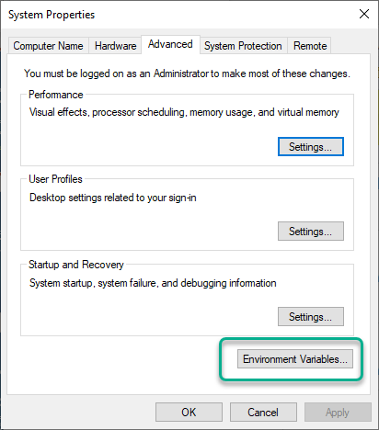
7. If you click on the Environment variables button, you can edit your system’s environment variables (one of which is the path variable). There are two path variables: one that is used for all users on the system, and one that is used just for your user. The search path is a combination of both paths.  
   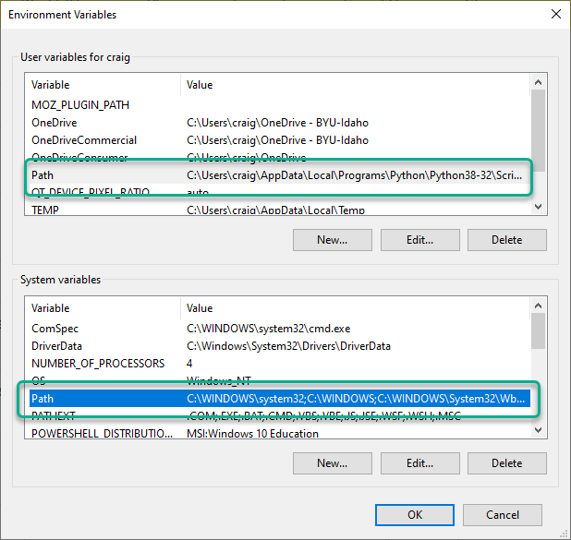

# Task 3—Expressions

PowerShell will evaluate any expression that you give it as soon as you press enter.

## Steps

1. Simple math
   1. Enter a simple math formula and press enter to see the results. Enter  
      42 * 17
   2. Record the answer here 714
2. Logic
   1. You can evaluate test conditions. Enter  
      'red' -eq 'Red'
   2. Record the result True
3. Manipulations.
4. Replace a word with another word. Enter  
   'my dog has fleas' -replace 'dog','cat'
5. Record the result my cat has fleas
6. Flexible numbers. How many megabytes are in a gigabyte?
   1. Enter a simple math formula and press enter to see the results. Enter  
      1gb/1mb
   2. Record the answer here 1024

# Task 4—History

The history feature of PowerShell makes life a lot easier.

## Steps

1. Use the history feature of PowerShell to retrieve a previous command.
   1. Press the up arrow until you see the line  
      'my dog has fleas' -replace 'dog','cat'
   2. Use the keyboard arrows and delete key to modify the word cat to say rabbit, then press enter.
   3. Record the result my rabbit has fleas
2. You can search your history as well. Find the route command we entered earlier using the search feature of history.
   1. Press **ctrl + r**
   2. Now type r, this will take you back to the most recent command that has a letter r in it. This is not the command we want
   3. Type o, this will find the most recent command that has the letter o in it. This is probably still not the command you want.
   4. Type u, now you probably are seeing the route command. If you do, just press enter to execute that command again.
3. You can clear your history if you would like. Give it a try.
   1. Press **Alt+F7**
   2. Try using the up and down arrows to scroll through your history. It should be gone.

# Task 5—Clear it up

When things get messy, clear it up.

## Steps

1. There are several ways to clear the screen. The easiest is just to press Ctrl + L. Give it a try.
2. You can also use the following command:  
   Clear-Host
3. Or even this command:  
   cls
4. Give them a try.

# Deliverable

Upload this document with completed answers to I-Learn.